Name : Fuad Bin Mohammad, Kennard Kee Comments:
Group : 2

Proposal/Report: Assignment 1 (Finite State Machine)
________________________________________________________________________

Design 2 FSMs (minimum 3 states) for game scene by circling states, conditions in written descriptive statements in space below. Draw the State Transition Diagram.

FSM # 1 States

If under fire, find cover (prone [-50% to hit] or wall)
If not under fire and no ammo, Move forward
If not under fire, has ammo, attack
If no ammo, reload
If hit by bullet, decrease HP
If HP is zero, die

Conditions

If under fire, find cover (prone [-50% to hit] or wall)
If not under fire and no ammo, Move forward
If not under fire, has ammo, attack
If no ammo, reload
If hit by bullet, decrease HP
If HP is zero, die

State Transition Diagram

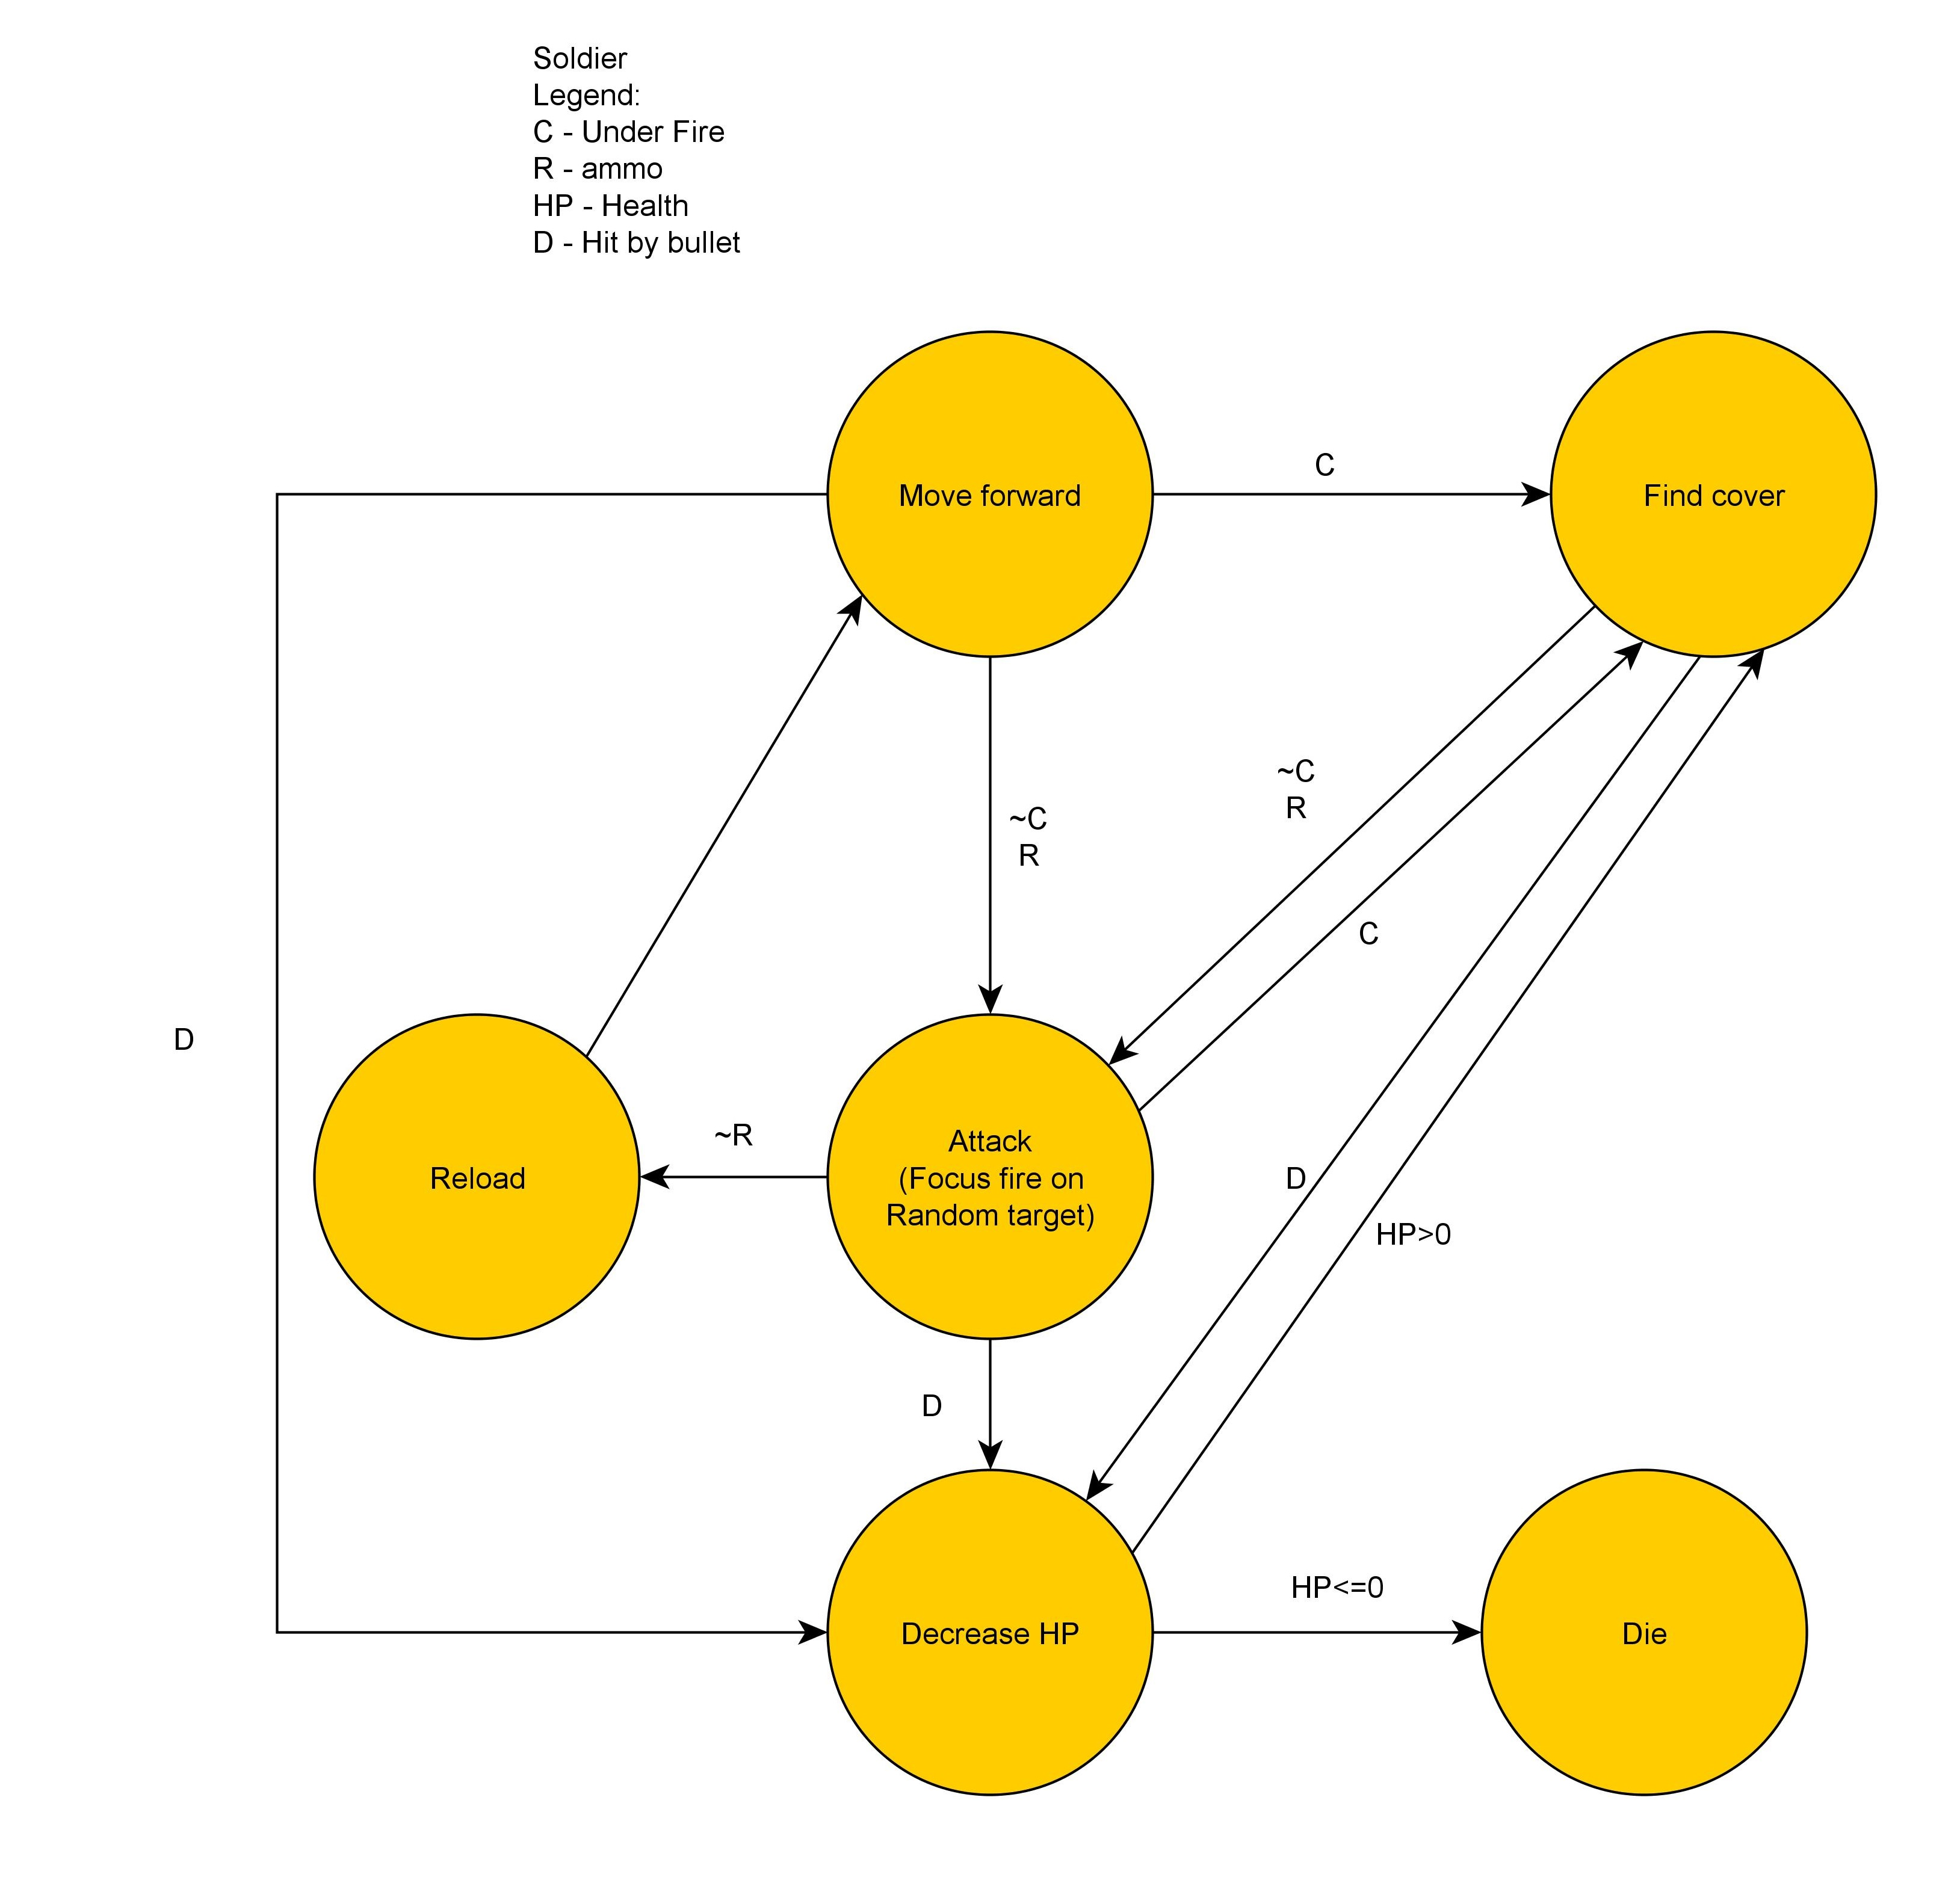

SOLDIER

FSM # 2 States

If turret request repairs, repair turret with lowest HP, use repair charges
If repair charge depleted, recharge
If none, idle (run from turret to turret)
If hit by bullet, decrease HP
If HP is zero, die

Conditions

If turret request repairs, repair turret with lowest HP, use repair charges
If repair charge depleted, recharge
If none, idle (run from turret to turret)
If hit by bullet, decrease HP
If HP is zero, die

State Transition Diagram
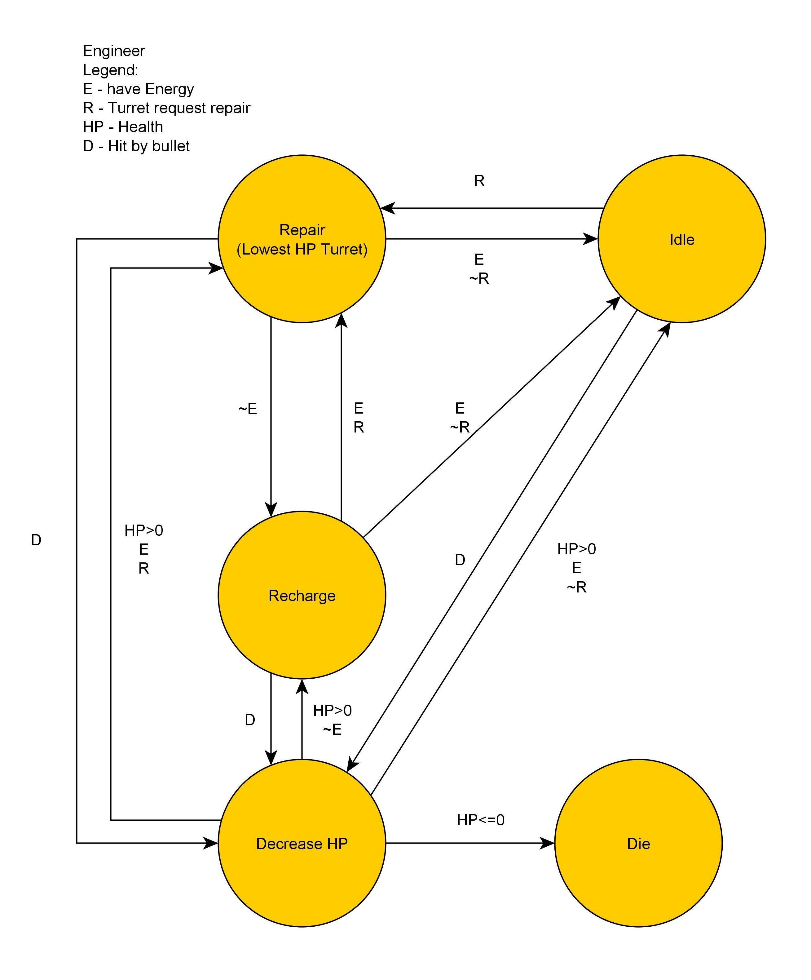
ENGINEER

FSM # 3 States

If has ammo, fire at soldier
If no ammo, reload
If hit by bullet, decrease HP (Damaged)
If damaged, request repairs
If no HP, dead

Conditions

If has ammo, fire at soldier
If no ammo, reload
If hit by bullet, decrease HP (Damaged)
If damaged, request repairs
If no HP, dead

State Transition Diagram
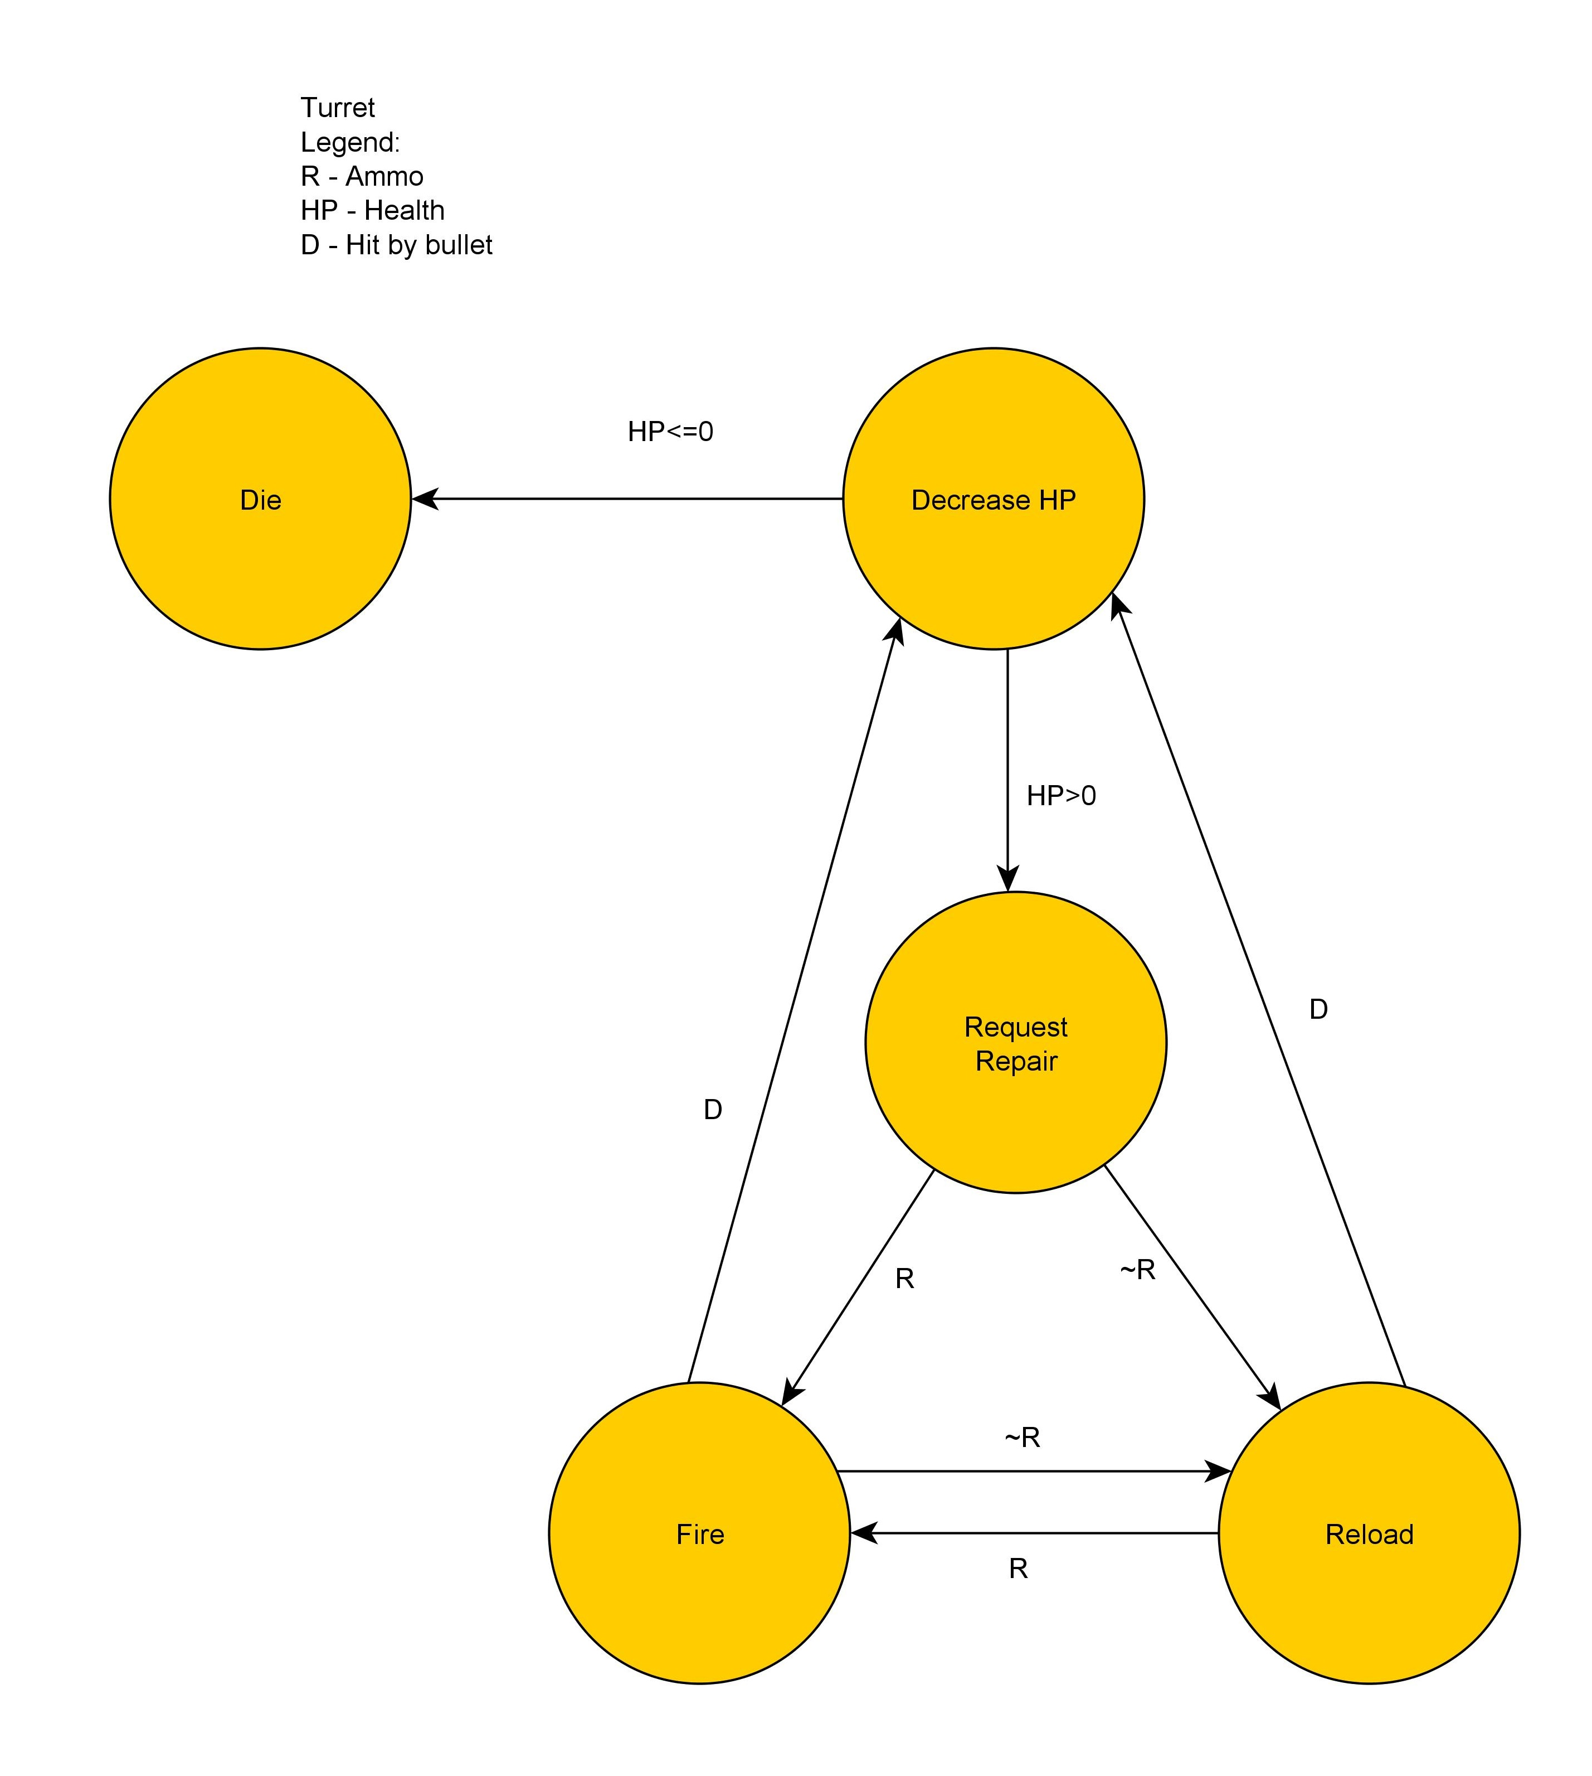

TURRET

Additional Information
For soldier when moving into cover there will be a sub state that will make the soldier move slower as well as have a 50% chance for bullets to miss
Soldier will have 10 HP
Worker will have 8 HP
Turrets will have 5 HP

Solider will shoot 7 bullets in a row before having to reload for 4 secs
Turrets will shoot 4 bullets in a row before reloading for 4 secs
Each bullet will deal 1 HP in damage
Engineer has 3 repair charges
Each repair charge heals a turret for 1 HP

